**Release 1**

**Sprint 1**

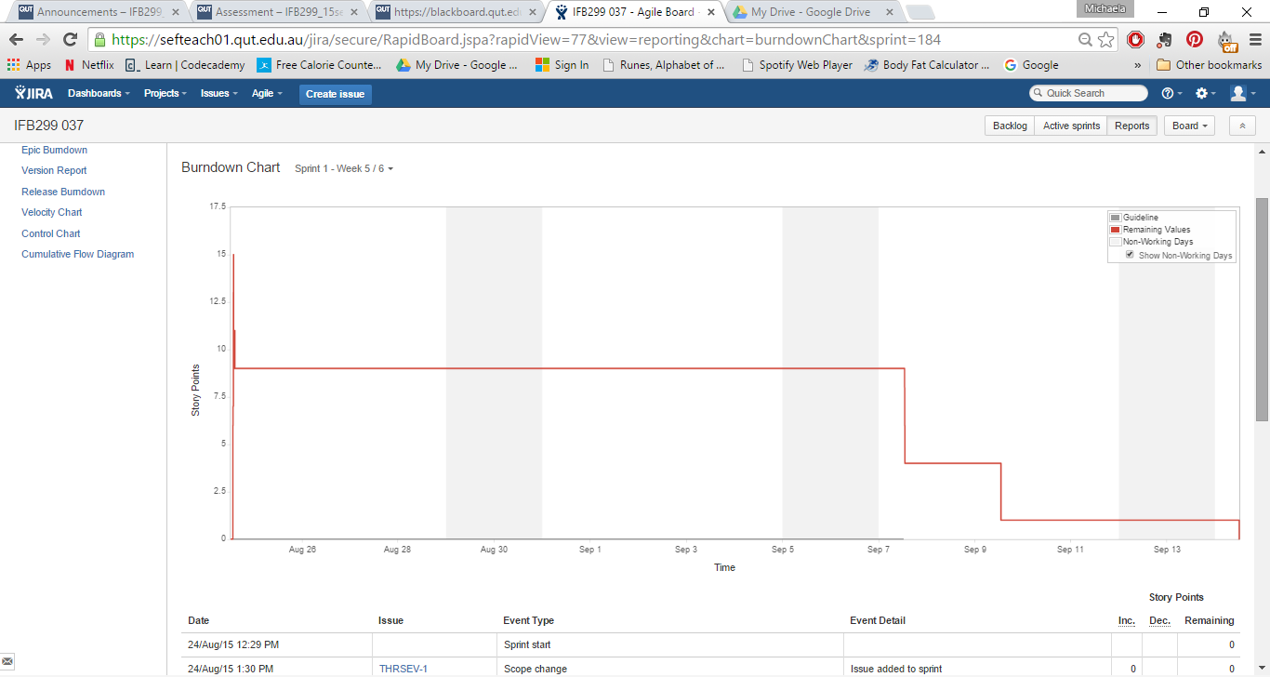

Scrum Monday (Week 6)

* J - tried to learn the website - worked out sql query
* N - Created 90% of contact us page
* P - setting up environment
* M - sort of figured out website - added comments

Scrum Monday (Week 7)

N - contact us page - finished

P - coding css  -faced issues - moved to backlog

J - attempted the sorting option - not finished

M - Property page + added pictures

**Sprint 2**

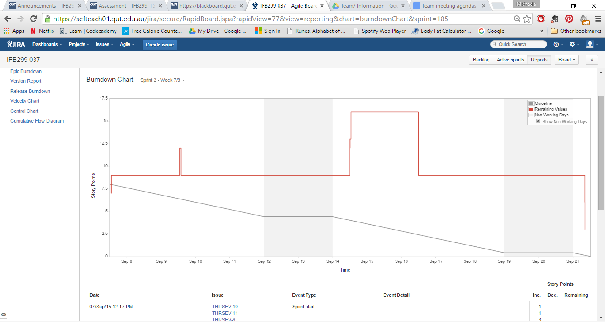

Scrum Monday (Week 8)

* N – Worked on Buisness Letter
* P – Buisness Letter, Created Storyboards for Website
* J – create the login page, create the add a website
* M – Working on Sorting properties, tidied up home page

Scrum (Week 9)

Yet to be done.